SECTION A

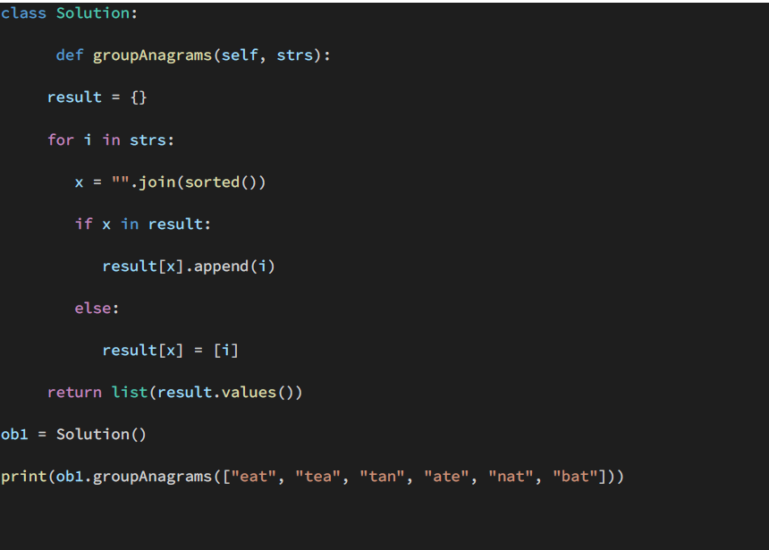

* **Correctness:** The code implements the desired functionality of grouping the anagrams together. The sorted strings serve as a key in a dictionary which stores the anagrams as values. The final result is returned as a list of the dictionary values.
* **Efficiency:** The implementation is quite efficient, with a time complexity of O(n*klogk), where n is the length of the input list and k is the maximum length of a string in the input list.
* **Style:** The code is easy to read and understand. The naming of variables is descriptive and follows PEP 8 guidelines. . However, there are some minor issues with the style ,the indentation is not correct the contents of the function groupAnagrams are not properly indentedalso The class name **Solution** is not very descriptive and should be changed to something more meaningful. Also, the **result** variable should be renamed to something more descriptive, such as **anagram_groups**.
* **Documentation:** The code lacks sufficient documentation. There are no comments explaining the logic of the implementation or the purpose of the functions and variables.

Overall, the provided code is correct and efficient but could use some improvements in style and documentation. Here are some suggestions for improvements:

* Rename the class to something more descriptive, such as **AnagramGrouper**.
* Rename the **result** variable to something more descriptive, such as **anagram_groups**.
* Add comments to explain the logic of the implementation.
* Add a docstring to the **groupAnagrams** method to explain the input and output.

Here is an improved version of the code:

